NovaTrust Bank
Analysis Process
Data Import
The four datasets (Branch, Customer, Product, and Transaction data) were imported into PostgreSQL. Tables were created with appropriate primary and foreign keys to establish relationships between the fact table (Transactions) and the three dimension tables (Branch, Customer, Product).
ERD
ERD for database to check the relationship between tables.
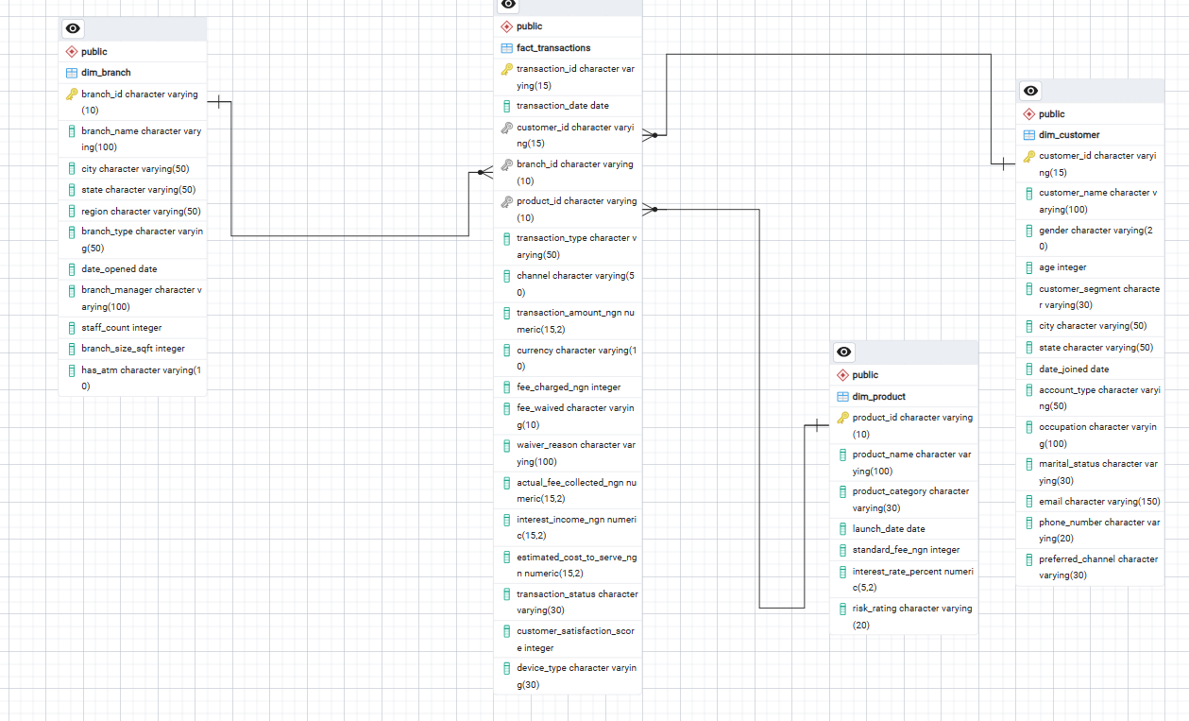
Data Cleaning (SQL)
Before analysis, the raw data was reviewed and found to contain several quality issues:
- Inconsistent text casing and extra whitespace across nearly all categorical fields (e.g., Gender, Customer Segment, Branch Name, Product Category, Transaction Type)
- Duplicate records: 15 duplicate Customer IDs and 60 duplicate Transaction IDs
- Acronyms incorrectly reformatted by standard capitalization functions (e.g., SME, FCT, NYSC, CEO, ATM, POS, USSD).
These were resolved using SQL UPDATE statements combined with TRIM(), INITCAP(), and CASE WHEN logic to standardize text formatting while preserving correct acronym capitalization. Duplicate records were removed using staging tables and DISTINCT ON.
Calculated Fields
Two new fields were added directly to the Transactions table using ALTER TABLE and UPDATE:
- Revenue = Actual Fee Collected + Interest Income
- Profitability = Revenue − Estimated Cost to Serve
Business Question Analysis (SQL)
All five business questions were answered directly in SQL using JOIN, GROUP BY, SUM, COUNT, and DATE_TRUNC to aggregate and analyze the cleaned data at the branch, customer segment, product, monthly, and fee-waiver level.
Question1:
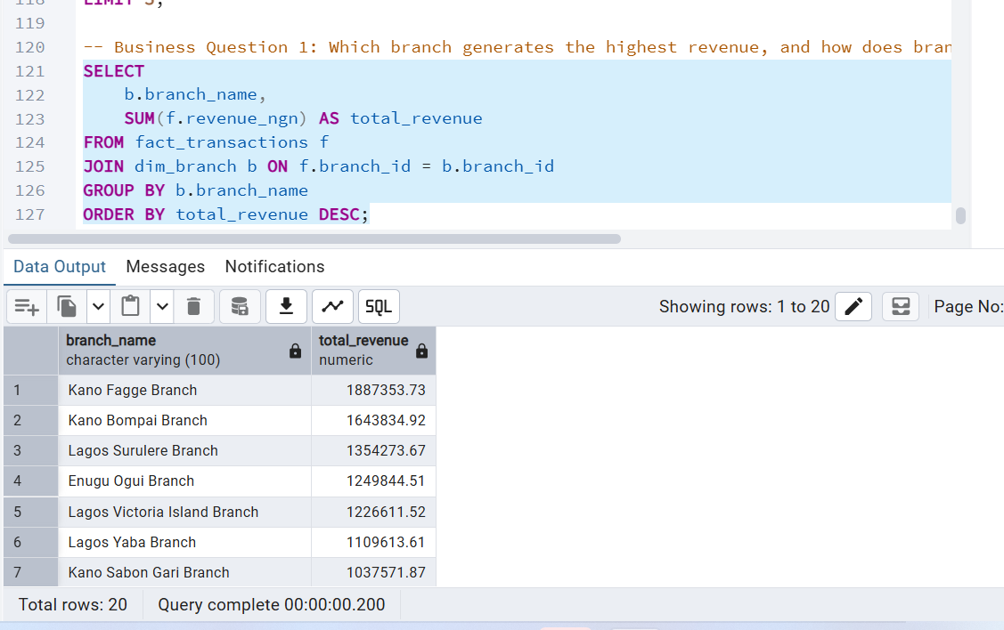

Question2: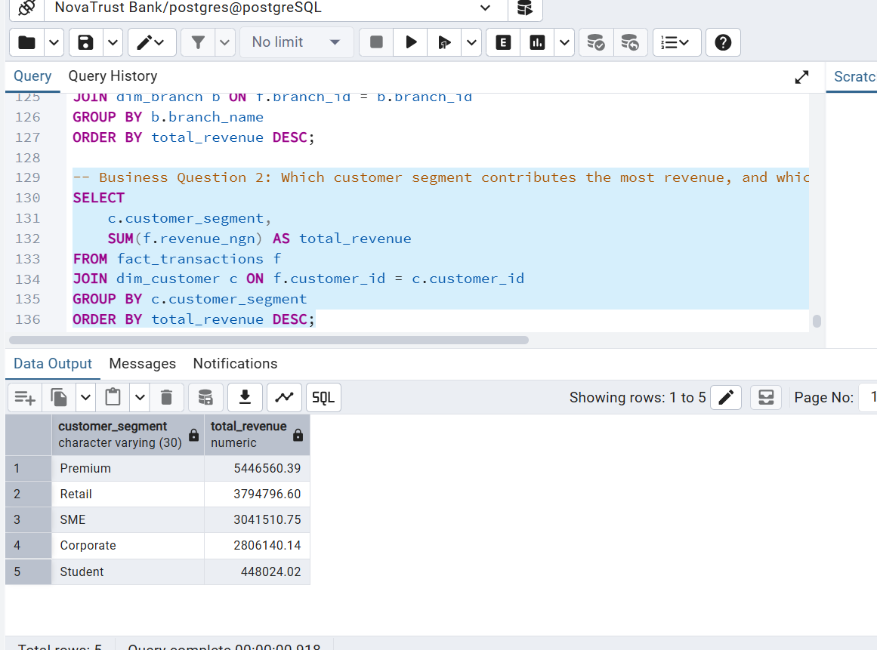
Question 3:

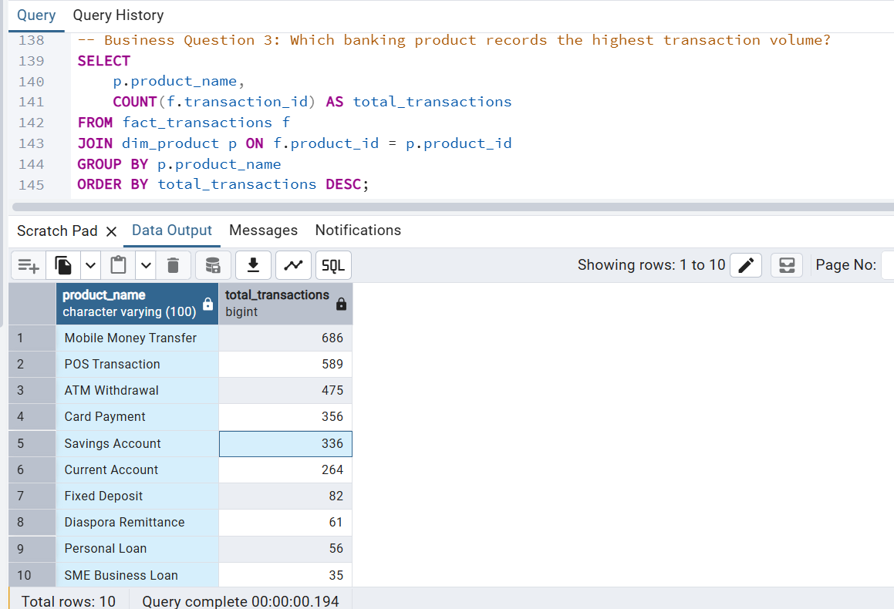

Question 4: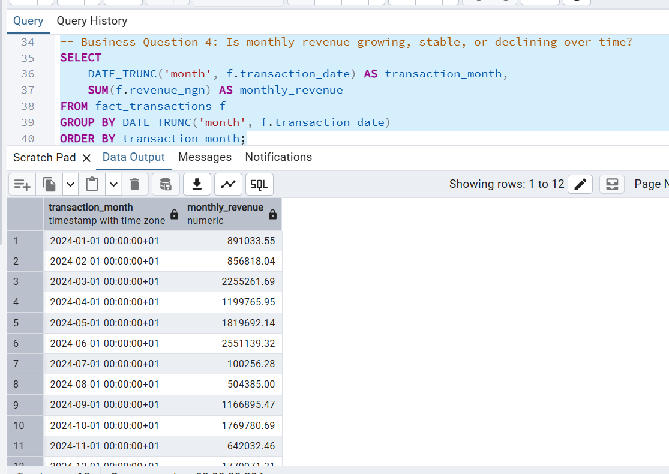
Question 5:

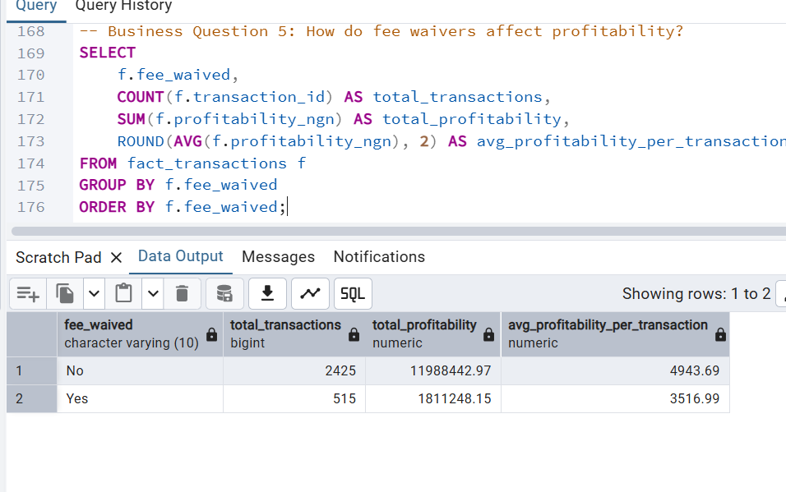
Export and Power BI Import
The cleaned tables were exported from PostgreSQL as CSV files and imported into Power BI. Table relationships (Branch, Customer, and Product to Transactions) were re-established in Power BI's Model view, mirroring the same relationships built in SQL. 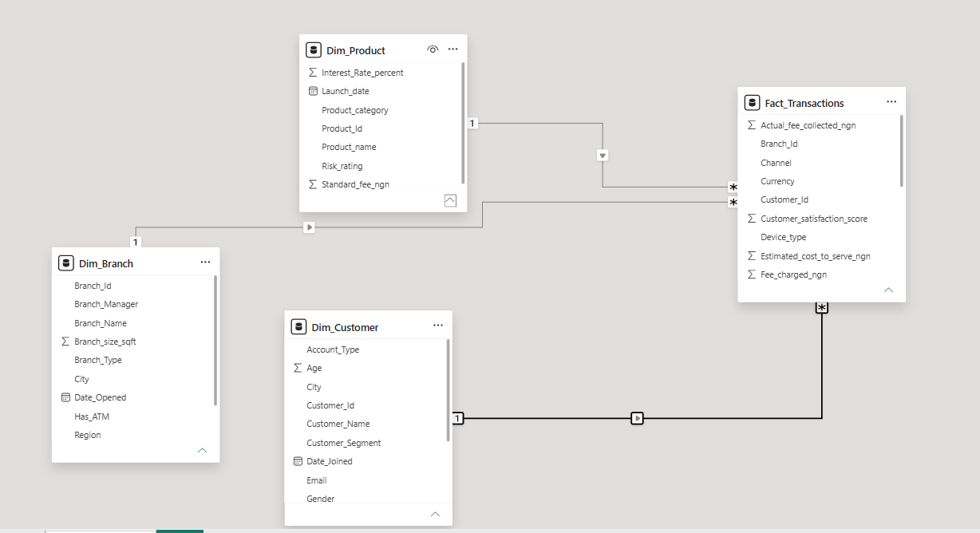
New Measures
Measures were created in Power BI to summarize the Revenue and Profitability fields (already calculated in SQL) for use across visuals and KPI cards.

Dashboard Design and Build
A wireframe was sketched using Power Point to design the dashboard layout. The final dashboard includes four KPI cards (Revenue, Cost, Profit, Transaction Volume), five visuals addressing each business question, and two interactive slicers (Region and Product Category) allowing users to filter the entire dashboard dynamically.
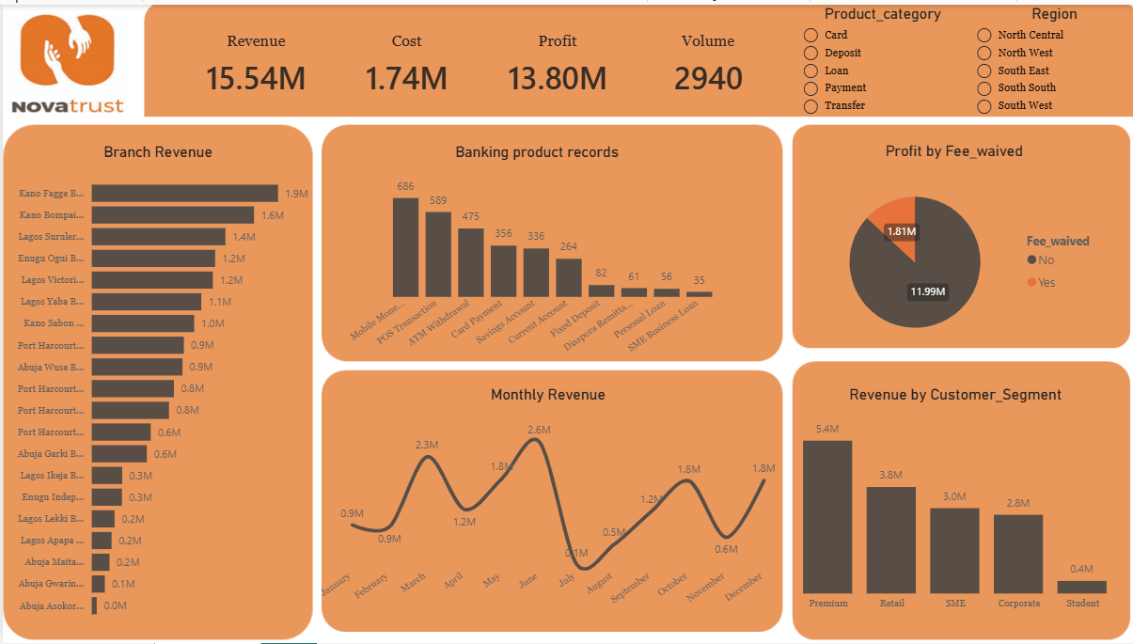

Dashboard Explanation
- The KPI cards at the top (Revenue =₦15.54M, Cost =₦1.74M, Profit =₦13.80M, Volume = 2,940 transactions) give management an at-a-glance summary of overall performance.
- The Branch Revenue ranks every branch by revenue, from Kano Fagge (₦1.9M) down to Abuja Asokoro (₦0.0M(49.93K)). This answers Q1, Kano Fagge is the top-performing branch, followed by Kano Bompai and Lagos Sururlere, while several Abuja and Lagos branches sit at the bottom, showing a wide performance gap across the network.
- The Revenue by Customer_Segment splits revenue across Premium (₦5.4M), Retail (₦3.8M), SME (₦3.0M), Corporate (₦2.8M) and Student (₦0.4M). This answers Q2, Premium customers contribute the most revenue, and the Student segment contributes the least by a wide margin.
- The Banking product records shows transaction volume per product, e.g. Mobile Money (686), POS Transaction (589), ATM Withdrawal (475), down to SME Business Loan (35). This answers Q3, Mobile Money and POS Transactions dominate transaction volume, while lending products (Personal Loan, SME Business Loan) see very little activity.
- The Monthly Revenue tracks revenue by month across the year, rising from ₦0.9M (Jan) to a peak of ₦2.6M (June), then dropping sharply to ₦0.1M (July) before partially recovering. This answers Q4, revenue is not stable; it is volatile with strong peaks (March, June) and a sharp mid-year dip (July), rather than showing steady growth.
- The Profit by Fee_waived chart splits profit by whether a fee was waived: ₦11.99M profit on transactions with no waiver vs ₦1.81M on transactions with a waiver applied. This answers Q5, fee waivers are associated with a much smaller share of profit, indicating waivers and promotional incentives are eating into profitability.
- The Product_category and Region slicers are interactive filters for product category (Card, Deposit, Loan, Payment, Transfer) and region (North Central, North West, South East, South South, South West), letting management re-run any of the above visuals for a specific product category or region to investigate root causes further.
Key insights identified:
- Branch performance is highly uneven: the top branch (Kano Fagge, ₦1.9M) generates roughly 40× the revenue of the lowest branch (Abuja Asokoro, near ₦0), so growth is concentrated in a handful of locations.
- Premium and Retail customers drive most revenue, while the Student segment contributes very little, there may be an opportunity (or a deliberate low-margin acquisition strategy) worth reviewing.
- Transaction volume is concentrated in low-value, high-frequency products (Mobile Money, POS, ATM Withdrawal), while lending products generate very little volume, which may explain why revenue growth is not translating into proportional profit growth.
- Revenue is volatile month-to-month rather than steadily growing, with a sharp July dip that warrants investigation (seasonality, system downtime, or a data/process issue).
- Fee waivers are associated with meaningfully lower profit (₦1.81M vs ₦11.99M), supporting management's concern that waivers and promotions are being offered without enough visibility into their profitability impact.

Recommendations
- Investigate and replicate top-branch practices. Study what Kano Fagge, Kano Bompai and Lagos Sururlere are doing differently (staffing, marketing, product mix) and replicate those practices in the lowest-performing Abuja and Lagos branches.
- Tighten controls around fee waivers and promotions. Introduce approval thresholds or a waiver budget per branch/segment, and track waiver usage against profit monthly so waivers are a deliberate, measured trade-off rather than an unmonitored cost.
- Grow high-margin products, not just high-volume ones. Mobile Money and POS drive volume but NovaTrust should assess the margin on each product line and design campaigns to grow underused but potentially higher-margin products (savings, fixed deposit, lending) rather than optimising for volume alone.
- Develop a segment-specific strategy for low-contributing groups. Re-evaluate the value proposition for the Student segment, either as a deliberate long-term acquisition play (converting students into higher-value segments over time) or by introducing tailored products that lift their contribution.
- The Monthly Revenue chart shows revenue peaked at ₦2.6M in June, then dropped sharply to ₦0.1M in July before slowly recovering. This is a big warning sign. Investigation should be carried out on what happened in July, a system outage, staff shortage, seasonal slowdown, or even a data entry issue, so it doesn't happen again.

